BLINKING OF TWO LED’S.

# OBJECTIVE:

The main objective of this project is to analyse the blinking of two LED’s using ATMEGA328p

microcontroller.

# INTRODUCTION:

To blink two LED’s using push button the main element here is ATMEGA328. In this, we will analyse the status of the two LED’s according to the input from a button switch. Every time when the controller receives input from the switch, it will blink the current status of the LED’s.

ATMEGA328 is a popular microcontroller due to it being a major component in the Arduino board projects. The ATMEGA328 is the 8-bit RISC heart of the Arduino UNO and Nano, with maximum clock frequency of 20MHz, 32KB program FLASH, and 2KB of RAM.

The push button switch is usually used to turn on and off the control circuit, and it is a kind of control switch appliance that is widely used. the push button switch can complete basic controls such as start, stop, forward, reverse rotation, speed change and interlock.

# COMPONENTS REQUIRED:

1. ATMEGA328 Microcontroller.
2. Light Dependent Emitter (LED) x 2.
3. Resistor 10k x 2.
4. Resistor 330Ω x 2.
5. Push Button.
6. Supply Voltage.
7. Ground.

# SCHEMATIC DIAGRAM:

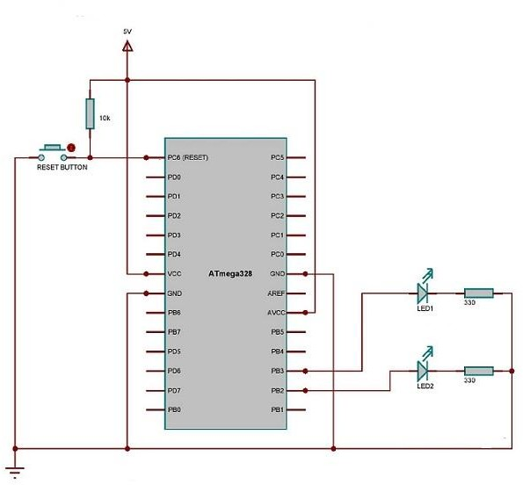

1. **ATMEGA328:**

ATmega328 is an AVR family micro controller. It is based on advanced RISC architecture. It is an 8-bit controller. It has 32K Bytes of Programmable Flash memory, 1K Bytes of EEPROM and 2K Bytes of SRAM. It has 23 programmable I/O pins. It supports peripheral features like two 8-bit timers, one 16-bit timer, 6 channel ADC with 10-bit resolution, programmable USART2 wire serial interface (I2C), etc.

# LED:

A light-emitting diode (LED) is a [semiconductor](https://en.wikipedia.org/wiki/Semiconductor) [light source](https://en.wikipedia.org/wiki/Light_source) that emits light when [current](https://en.wikipedia.org/wiki/Electric_current) flows through it. [Electrons](https://en.wikipedia.org/wiki/Electron) in the semiconductor recombine with [electron holes,](https://en.wikipedia.org/wiki/Electron_hole) releasing energy in the form of [photons.](https://en.wikipedia.org/wiki/Photon)

1. **PUSH BUTTON SWITCH:**

A Push Button switch is a type of switch which consists of a simple electric mechanism or air switch mechanism to turn something on or off.

# WORKING:

First, we will connect the 2 LED’s with PB2 and PB3 of PORTB of the ATmega328

microcontroller. Then, we will make the 2 LED’s to blink with an interval of 1 second. It means, initially the 1st LED alone will glow and on the next second, it will turn off and the 2nd one will glow. This process continues forever and in this way LEDs blinks continuously.

# ADVANTAGES:

* 1. Long Lifespan.
  2. Energy Efficiency.
  3. No Heat or UV Emissions.
  4. Improved Environmental Performance.
  5. Processors are simpler to use, with the usage of 8bit and 16bit instead of 32/64bit which are more complex
  6. Optimized for AVR enhanced RISC instruction set.

# DISADVANTAGES:

1. Lacks performance compared to higher bit microcontrollers.
2. High Up-Front Costs.
3. Transformer Compatibility.
4. In Push Button the key fob could easily be forgotten.

# APPLICATIONS:

1. LED’s are used in digital watches ,Microprocessors and multiplexers.
2. ATmega328 is commonly used in many projects and autonomous systems where a simple, low-powered, low-cost micro-controller is needed.

# WHEN LED IS OFF:

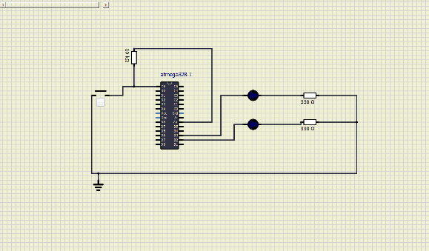

**WHEN LED 1 IS ON:**

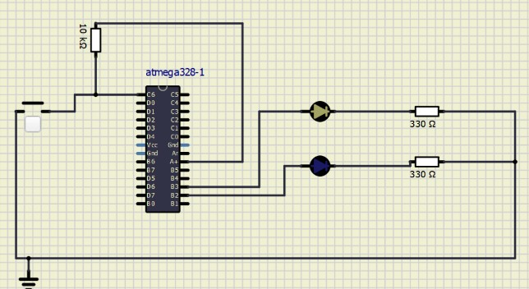

# WHEN LED 2 IS ON:

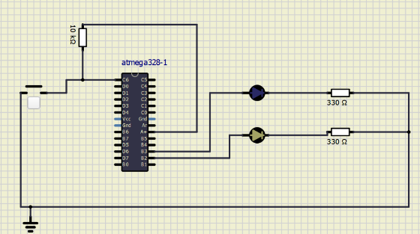

**RESULTS:**

By using ATMEGA328 simulated the above simulations by load firmware in the

microcontroller. And observed the blinking states of the two LED’S by using the push buttons. And

accurate results are been observed.